**ALTUI Plugin for VERA / Lite / Edge on UI5 or UI7**

Micasaverde /GetVera is producing a product family of zWave controllers called Vera 3, Vera Lite and Vera Edge now. These product come with a user interface layer called UI and which exists in 2 versions as we speak : UI5 and UI7.

Unfortunately the long awaited UI7 has been kind of a disappointment , especially with its unresponsiveness , not really well optimized screen real estate, and difficult to deal with for 3rd party plug in writers. It was also promising a mobile user interface and the application does not resize well on phone or on desktops and the mobile version of the application is not user friendly.

I started to work on a UI replacement.

This document covers:

1. The overall project objectives & “big” rules
2. The screen shots
3. The installation instructions
4. Some internal explanation of the source code & architecture

Table of Contents

The project initial objectives 2

Objectives 2

DONE and functional so far 3

Screen shots: 9

UI5 Installation Instructions (similar for UI7) 49

Architecture and Source Code organization 70

Extensibility 71

Mechanisms to extend 71

Javascript modules for customizable plugins 71

Full Source code 72

Source Files: 73

Basic rules for developers: 76

# The project initial objectives

I am not fully satisfied with UI5 or UI7 and I think we can provide very quick improvement. French users of Orange HomeLive system on internet seems to be Highly largely unsatisfied by the UI and we could improve this relatively easily adopting a refreshed approach & architecture. ( remains to be seen if orange is going to be open to this but we should try )

## Objectives

1. **Fast & immediately responsive** ( except LUA Jobs of course, cant control that ). Asynchronous / threaded programming as much as possible.
2. Avoid the classic UIx issues with too many **heterogeneous js frameworks**, inconsistent CSS rules requiring ticks all over the place and overuse of the “! Important”
3. Does **not** **require** **anything** other infrastructure than the **VERA** itself and a simple plugin. No PHP, No DB, No additional server running. Just plain VERA
4. Really use the **power of the client side** machine ( big processors & memory ) and far less the Vera side.
5. Works well on all screen size**, full responsive design** using bootstrap
6. Really use [**bootstrap**](http://getbootstrap.com/) facilities for responsiveness, should work on Phone 4S as well as tablets, as well as desktop / large screens. Same app, same code, same access url
7. Skinnable using Bootstrap themes
8. Dashboards should be optimized in screen real estate. **Undo the UI5 design decision** which links the Scene editor with the dashboard. You can only put in scene what is in the dashboard ( unless you use the advanced feature ). Dashboard requires maximum use of the screen real estate, Scene editor is something else.
9. Plugin authors should be able to control the display of their device using a s**imple javascript functions** , even on the dashboard page. Should not be limited to a VERA Box api or any complex undocumented json behaviors. Just a dynamically loaded javascript which can make full use of bootstrap & useful libraries provided
10. **Full reuse of dynamic icons** ( don t want to recreate icons or each plugin logics here ) from the json descriptions
11. **Dashboards should customizable by the end user,** he choses the pages and the devices he wants to see ( not done yet at this point ! )
12. reuse of UI7 json descriptions for dashboards, control buttons etc
13. Works on UI5 and UI7 with minor degradation on UI5 ( housemode for instance )
14. Localizable

### DONE and functional so far

I already uses this more than UI7 on my ipad/phone and desktop at home. So far achievements are the following:

**An alternative UI for VERA boxes based on UI5 UI7**  
  
This plugin offers an alternative user interface for your VERA(s) controllers that is more pleasant and works on any kind of device as a web application which will automatically adjust to screen size  
  
It works as a simple plugin and you just need your browser. it supports UI5 and UI7 veras and can aggregate in the same screen the devices from multiple seperate VERA boxes.  
It is not just a re skin of UI5/7, and will offer a number of additional feature  
  
**LATEST VERSION** : v 0.78.718 Sept 20th 2015 :   
  
**Extra features not present in UI5 UI7**:

* Fully responsive design / all form factors supported , no need to install a new application on your mobile
* Fully skinable based on bootstrap 3 css. fixed background image / transparency
* works equally well on UI5 and UI7 boxes and thus offers an enhanced experience even on older boxes without adding load to your controller. it maximizes the power of our modern browser and seldomly relies on the VERA controller
* works with **multiple VERA controllers**, you can see & interact with devices and scenes of multiple controllers transparently. (but no support for secure vera)
* user defined custom synoptic panels
  + made of elements out of your devices ( variables, actions, images, text ) but also cameras,  graphical gauges, box frames
  + can mix and match devices from multiple VERA controllers (but no support for secure vera)
  + nice Hi/FI like on/off button
  + nice analog gauges to display a chosen device variable value
  + with a full Wysiwig editor mode for pages
  + drag and drop of control to add/remove and aligns
  + selectable page background with CSS3 property : gradiant, images or even video background if you want !
* extensible design with javascript modules for plugins dashboard & control panels
* compatibility with most 3rd party plugins (IPhone locator google map), all but a few custom devices are controllable.
* all custom icons are displayed , even in remote access mode
* Complex graphics made with D3JS library, animated graphs for device parent child relationships, zWave neighbors, zWave routes & route quality.
* Power/Energy consumption graph
* Parent Child relationship on a force layout d3js map
* zWave neighborhood map with color based on PollOk % status. Click able node on zWave map
* zWave Route Quality Chart
* Table of device with choose able / sortable columns and ability to export
* trigger remote execution of user chooseable unix OS command and display output.
* History button to automatically display Scene last Execution timestamps from the lua log files
* Device: Variables displayed ordered alphabetically and with enhanced display format ( dates shown as dates, url as url )
* Device: Variables just click and edit, no messy checkbox to edit variable even to enter JSON or special characters
* Device: detailled view of utilisation in scene actions or triggers
* History button to automatically display Device Variable Changes from the lua log files
* supports lua log and ANSI color display
* Auto detection of new version & updates
* Client device specific Favorite device / scene selection ( your favorites may be different on your phone or your pc)
* Persistence of settings, preferences, filtering selection in various screens
* Powerful filter on pages ( by category, room, name, battery )
* Visible battery status
* Plugin page: List of installed, direct button to reach the store, update from store, uninstall, to reach help page from the author, direct button to view content/download plugin files
* Plugin page: plugin files selectio and easy content display in editor
* Display of manually installed plugin
* Camera: live video feed in local mode, images in remote mode
* Debug tool screen enabling to get all device information, to get one device / all variable info, to search all devices for a given variable name (pattern matching), or to call a javascript piece of code, including the ALTUI object apis
* Scene trigger can be a **device variable watch** without any line of LUA code

**Features equivalent to UI5 UI7**:

* local and remote access via UI7 MMS authentication servers
* fully featured for room devices scenes plugins
* Room: List, Create, Rename
* Scene: List, Execution, Create, Edit ( triggers, timers, actions, event lua code, time restriction, housemode selection )
* Scene Mode selection  ( UI7 only )
* Scene Pause feature : in one click
* Trigger time range restriction ( new feature of latest UI7, now in AltUI too )
* Device: List, responsive design page, "as you type" Filter by name/category/room
* Device: small dashboard panels to fit many device on one screen. Dynamic icons as defined by the plugin author in the JSON file
* Device: Variables: List & Edit with enhanced display format ( dates shown as dates, url as url )
* Device: Notifications on events, Notifications to users
* Device: UpnP Actions: List & trigger with parameters
* Device: Control panel: per the static JSON file of the author. Display "flash" and "javascript" tab. In addition it can be customized via a ALTUI plugin.
* Device: Attributes: List / Edit with enhanced display format ( dates shown as dates, url as url )
* Device: UpdateNeighbours feature in device Actions dialog box
* Custom pages: Use mode (kiosk) and Edit. User can create its own set of custom pages by drag and drop of widgets   
  like device icon, web images, device action button, device variable/labels, camera picture or google gage.   
  Alignment tools to create nice looking panel, customizable background by css3 ( images, gradiant... ), persistent storage of the pages on the VERA box by the LUA plugin
* Lua test code editor / Lua startup code editor
* scene editor
* Plugin management ( install,  updates, deletes )
* language aware ( EN FR IT provided ) , open design to add other languages as well
* Compatible with most plugins including those with javascript tabs using the UI5 UI7 javascript API. like the RGBW plugin support

**Customization**

* Each device type can have its own custom panel : Datamine, Infoviewer, Weather, Light sensor, Holiday plugins, IPhone Locator, IPX800
* Simple javascript API to dynamically load custom plugins to display device small panels,   
  device large control panels, device icons. ask me for details, but basically you do not need to master lots of things as long as   
  you know how to use jquery and to write HTML elements in a parent container. I will integrate your contributions
* Display of Watts & last trip date on device dashboards
* Skinnable based on bootstrap styles you can find on <https://bootswatch.com/>
* Extensible architecture ( device dashboard & panel can be extended by a custom JS module ). developpers are welcomed to contact me on how to do this.  There is a UPNP action called registerPlugin() for plugins to dynamically register with ALTUI, @reneboer used it and explained here:<http://forum.micasaverde.com/index.php/topic,30310.msg242498.html#msg242498>
* Selectable home page by a url parameter ( home= )
* Selectable language by a url parameter ( lang= )
* language list extensible by a simple javascript, ask me & contribute if you want
* Themes & Styling
  + you can take a bootstrap CSS from any bootstrap 3 CSS web sites out there providing template, or you can start from the default
  + you then create your own CSS file which is incremental to that initial base
  + you put that CSS file somewhere ( I put mines on my google drive ) , you can put it on your vera under /www and point to it if you are concerned about working without internet dependency.
  + if your css file points to a bitmap, you will also need to put these bitmap file somewhere, note the url and make your CSS point to it. your CSS typically include things like :   
    background-image: url(<http://ssssssss/mycss.css);>
  + you declare the path of that CSS into the variable **ThemeCSS** of your ALTUI device
  + you reload ALTUI/refresh browser
  + **Example**: I provided the working example of fixed wood texture background with transparency in the "Styling" folder in the code.mios.com repository that you can access: <http://code.mios.com/trac/mios_alternate_ui/browser>
  + More info on theming: <http://forum.micasaverde.com/index.php/topic,30310.msg243792.html#msg243792>

Although the prefered way to customize the display of a device in ALTUI is to write a small javascript plugin,   
ALTUI provides a fast and easy customization of display of a device by the mean of 2 reserved service/variables   
that can be added manually by the user to any device. ID = 'urn:upnp-org:serviceId:altui1' , Variable = 'DisplayLine1' and 'DisplayLine2'

1. you add the variables to the device.
2. if no drawing plugin is specified , then altui will look for these variables, if found, it will display one ( or both )   
   per line. each variable text content is included in a <div> which has a CSS class called altui-DisplayLine1 or   
   altui-DisplayLine2 for possible theming if needed. Variable content will be HTML encoded so that HTML injection is not possible
3. if no drawing plugin is specified and if ALTUI does not find these one of these 2 variables, it will display the default   
   ellipsis glyph , signifying "default drawing"

**Prerequisite requirements**

* Just a classical plugin , no extra HW or servers

**HOW TO USE / LOCAL and REMOTE ACCESS**

* UI5 & UI7 local access: http://<yourip>/port_3480/data_request?id=lr_ALTUI_Handler&command=home#
* optional parameter:  lang=ll for language ( fr,en,it ) , home=xx where xx is one of pageHome, pageUsePages, pageDevices, pageScenes to force a start page
* UI7 remote access: <https://vera-ui.strongcubedfitness.com/Veralogin.php>
* UI5 remote access : method explained here =><http://forum.micasaverde.com/index.php/topic,30310.msg225132.html#msg225132>

**OFFICIAL VERSION   in Mios store**

* <http://apps.mios.com/plugin.php?id=8246>

**INSTALL**

* official version : by the store or the UI7 "Apps' menu.
* latest version : accept the autoupdate dialog box proposal , or install by opening this link in your browser    
  http://<yourip>:3480/data_request?id=action&serviceId=urn:micasaverde-com:serviceId:HomeAutomationGateway1&action=CreatePlugin&PluginNum=8246&Version=28922  
  ignore error messages displayed by this page and wait until your unit reloads...

**ALTUI Device VARIABLES**

* **PluginConfig**: JSON structure to configure ALTUI optional modules. a UPNP action registerPlugin() can be used to programmatically add a ALTUI-plugin for custom device drawing
* **RemoteAccess**: remote access url for MMS login
* **ThemeCSS**: a full url to download a CSS skin for ALTUI
* **UI7Check**: true if running on UI7
* **Version**: the LUA plugin version
* **LocalCDN**: a full path name from VERA root '/' where the necessary files for ALTUI are stored. can be left empty and ALTUI will get files from the internet but this option enables an internet free operation of ALTUI
* **ExtraController**: a optional , comma seperated list of additional VERA controllers to use. the main controller must not be listed and this variable can be left emtpy if you use only one VERA with ALTUI
* **Debug**: 1 for extra debugging logs
* **Data_xx_xx** variables : internal storage for ALTUI user pages definitions
* **Data_CustomPages_0** : JSON array of user custom page names
* **VariablesToWatch**: semi column ';' seperated list of watch variable instructions. Each watch is instructions is in this format : "service,variable,deviceid,sceneid,lua_expr,blockly xml".  
  sceneid is the scene to run if the lua expression is true. lua expressions uses old and new as variables for the watched variable where old = previous value and new = new value. example:  
  urn:micasaverde-com:serviceId:SceneController1,LastSceneID,208,71,(old==2)and(new==1) (the xml is optional and only there if the expression was edited with the Blockly editor).   
  ALTUI scene editor will take care of editing this **VariablesToWatch** variable.

**UPNP ACTIONS**

* registerPlugin(newDeviceType,newScriptFile,newDeviceDrawFunc,newStyleFunc,newDeviceIconFunc,newControlPanelFunc)/li]

**Some DOCs in French**

* Generic Introduction & Tutorial : <http://code.mios.com/trac/mios_alternate_ui/export/100/Doc%20FR%20ALTUI%20-%20Part1.docx>
* Custom Page Tutorial : <http://code.mios.com/trac/mios_alternate_ui/export/100/Doc%20FR%20ALTUI%20-%20Part2.docx>
* Extension coding tutorial : <http://code.mios.com/trac/mios_alternate_ui/export/100/Doc%20FR%20ALTUI%20-%20Part3.docx>

**Overall DOC in English** : 

* <http://code.mios.com/trac/mios_alternate_ui/export/245/doc.docx>
* <http://code.mios.com/trac/mios_alternate_ui/export/245/doc.pdf>

**BLOG & Web Magazine**

* AltUI, an introduction: <http://www.domotique-info.fr/2015/04/altui-pour-vera-une-alternative-ui5-ou-ui7/>
* Custom Page tutorial: <http://www.touteladomotique.com/index.php?option=com_content&view=article&id=1444:altui-user-interface-alternative-pour-vera-custom-pages&catid=5:domotique&Itemid=89#.VTewKFXtlBc>
* Extensibility for programmers : <http://www.touteladomotique.com/index.php?option=com_content&view=article&id=1445:altuin-user-interface-alternative-pour-vera-extensions&catid=5:domotique&Itemid=89#.VTi-C1Xtmko>

**SOURCE code**:   
Read only access to everybody on <http://code.mios.com/trac/mios_alternate_ui/browser> but for non commercial use.  
  
**COST**

* Free for non commercial use but please consider the option to:
  + Donate via the paypal button to support the effort
  + Rank the app in the app store
  + Make noise in the forum:)

# Screen shots:

|  |  |
| --- | --- |
| LUA plugin | Plugin Setting for configuration :  Open => launch the ALTUI window  Dynamic configuration for additional modules/plugin display functions  Reset config to default  Open & View configuration in a online json viewer |
| Remove Access via MMS servers for UI7 boxes | Step 1:    Step2: |
| Home mode selection  White & dark theme  Display of favorites scene or devices as responsive sized and clickable Tiles. |  |
| Room list and create/delete actions |  |
| Scene list and execution |  |
| Device Main page  color coding of headers according to device state.  State icons & dynamic display icon logic completely reused from the Vera files JSON description files of vera plugins |  |
| Tooltips with device attributes |  |
| autocomplete filter box |  |
| Ability to filter on device Battery,  Display of battery levels |  |
| Click on device title to rename |  |
| Device Control Panel screen emulate VERA and **display the same control panel as the “flash” tab of the device on VERA**  Button are functional are trigger UPNP actions.  “UsedIn” button to show how a device is used in triggers & scene actions |  |
| Default control panel can be overridden by a custom JS panel. Example for the CPLUS plugin |  |
| Camera support.  Click on thumbnail to view  Or gointo the device control panel  In REMOTE mode: get snapshot of images  In LOCAL mode: get **direct video** stream |  |
| Optional display of device attributes &  In DEBUG mode only ( flag on the LUA device )  We can see the  Control tab json definition ( for debug ) |  |
| Fully Responsive design that works on iPad or even iPhone 4S small screen  On iPad for instance, it adds columns when you rotate the iPad |  |
| Device variables presented. Timestamp presented as dates , url as clickable url |  |
| Edit device variable by click into , then click out |  |
| History of variable changes ( based on Lua logs ) |  |
| Device UPNP action & parameters callable from the user interface.  UPnp definitions dynamically read from the D_ & S_xx files |  |
| Installed Plugin screen and Update with a button | Click on “I” directly brings to Apps Store  Click on “update” triggers an update of the plugin from the apps store  Click on “?” opens the developper HELP page  Select a file opens the file content display page ( cf next slide ) |
| File content display box |  |
| Message Box for messages.  Badge for repeated messages. |  |
| Example of “grouped” error message with a badge number while LUA is restarted for instance |  |
| Modify Lua Startup editor |  |
| Lua test code |  |
| Scene editor  Triggers can be device Events or device variable watch with a lua expression |  |
| Device variable watch expression can be edited with Blockly |  |
|  |  |
| Lua event trigger ( does not exist any more in UI7 but it works fine ) so I added it back with a test code button right there  Trigger timing restriction |  |
| OPTIONS and User controllable Cache | Cache for Icons ( in remote access, icons are delivered as data uri , base64 and can be cached by the app )  Cache for device pnp files ( D_xx S_xx ) to avoid reloading when not needed.  Cache for last user_data to optimize useage from remote location. |
| OS commands with editor of favorite commands |  |
| Credits |  |
| Plugins / Custom device |  |
| ZWave Network neighborhood view |  |
| Power Energy |  |
| Parent Child force layout diagram |  |
| Table with selectable and orderable columns |  |
| Multi Controller mode |  |
| DEBUG tools |  |

# Skins

AltUI is based on bootstrap and can accept any bootstrap theme as a base skin. The AltUI device has a variable called ThemeCSS which should contain a url to a .css file like a bootstrap theme. You can download some bootstrap theme from here for instance.

<https://bootswatch.com/>

in this example, I have put a bootstrap theme file in my google drive account and gave it a public access & url such that it can be downloaded by AltUI

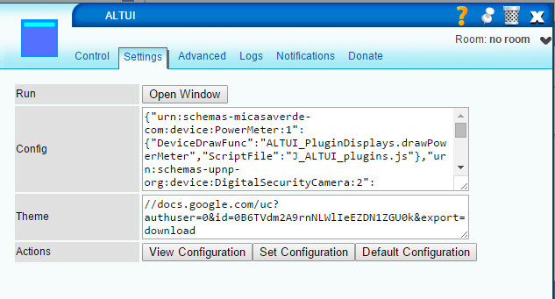

The result is this for instance:

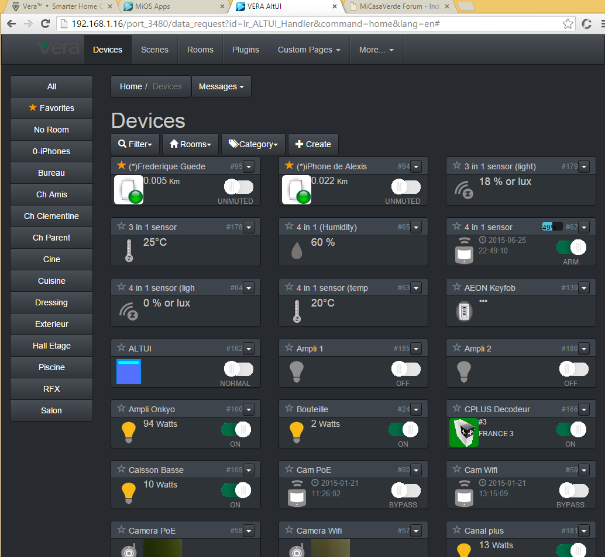

# Localization

AltUI will detect the browser preferred language and uses it to download an extra javascript file called J_ALTUI_loc_xxx.js where xxx is the language reported by the browser javascript engine:

|  |
| --- |
| var language = **window.navigator.userLanguage || window.navigator.language;**  if (language != 'en')  UIManager.loadScript('J_ALTUI_loc_'+ language + '.js' ); |

Then the J_ALTUI_loc_xxx.js contains string translations which will be applied automatically in AltUI

|  |
| --- |
| Localization.init( {  "Home": "Maison",  "Welcome to VERA Alternate UI": "Bienvenu dans AltUI pour VERA",  "Rooms": "Pieces",  "Devices": "Périphériques",  "Control Panel": "Controle",  "Scenes": "Scènes",  "Scene Edit": "Edition de Scene",  "Plugins": "Plugins",  "Custom Pages": "Pages Utilisateur",  "Edit Pages": "Pages Editeur",  "Credits": "Crédits",  "LuaTest": "LuaTest",  "LuaStart": "LuaStart",  "Optimize": "Optimise",  "Editor": "Editor",  "Custom Pages Editor": "Editeur de Pages",  "LUA Startup": "LUA Startup",  "LUA Code Test":"LUA Code Test",  "Optimizations": "Optimisations",  "Unmuted,Muted":"Normal,Mute",  "Normal,Debug":"Normal,Debug",  "Up":"Haut",  "Stop":"Stop",  "Down":"Bas",  "Open":"Ouvre",  "Unlock,Lock":"Unlock,Lock",  "Bypass,Arm":"Libre,Armé",  "Use Custom Pages":"Utilise Pages",  "Edit Custom Pages":"Edit Pages",  "More":"Plus",  "Remote Access Login":"Accès à Distance",  "Reload Luup Engine":"Redemarrer Luup",  "Lua Startup Code":"Code Démarrage Lua",  "Lua Test Code":"Code Test Lua",  "Localization":"Localisation",  "Misc":"Divers",  "Create":"Créer",  "Runs in mode": "Exécute seulement en mode",  "Run" : "Exécute",  "OFF,ON":"OFF,ON",  "Working":"Travail",  "Holiday":"Vacances",  "Wind":"Vent"  }); |

Localization control is visible in the “More “ Menu and shows all not localized terms found:

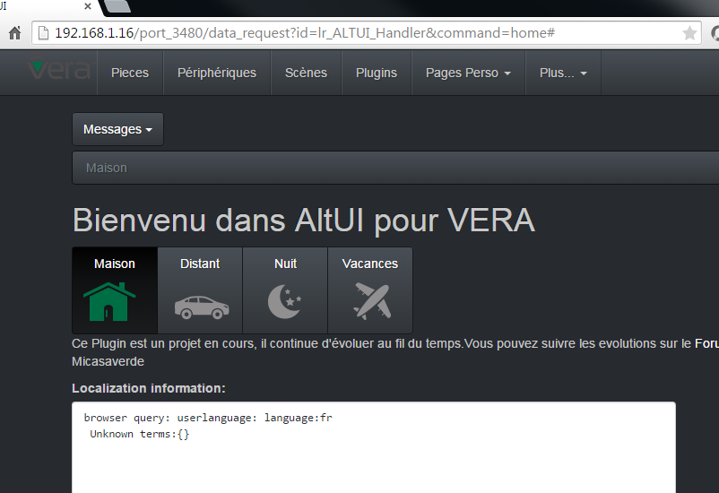

# Custom Pages

The following below explains the concept around custom pages. Example:

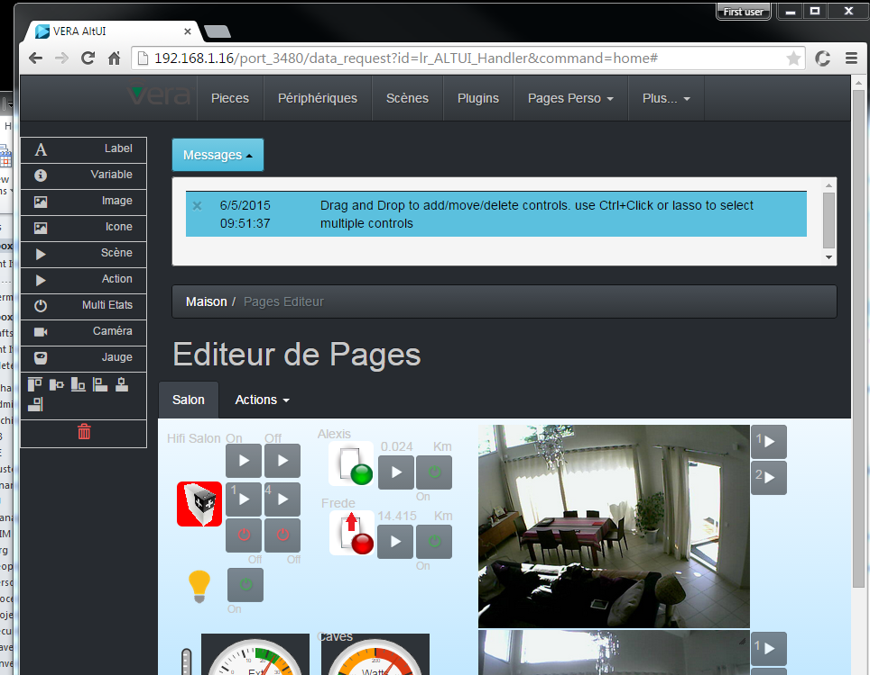

You can basically create your own panels and retrieve these panels whenever you want. For this you have 2 new Menu commands

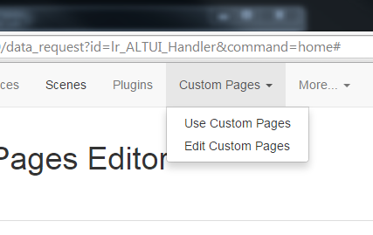

* Use Custom pages : just for readonly use of a custom panel you have built
* Edit Custom pages : to edit the panel.

The first time you go there, you will not see any custom pages as you have not created any yet. So let’s start by going into Edit mode first.

On the left, you have a list of tools in a toolbox. For now there are 3 tools:

* The Label one : to show a static label
* The Variable one : to display a current device variable value
* The trashcan : to delete a widget from a panel screen by drag and drop.

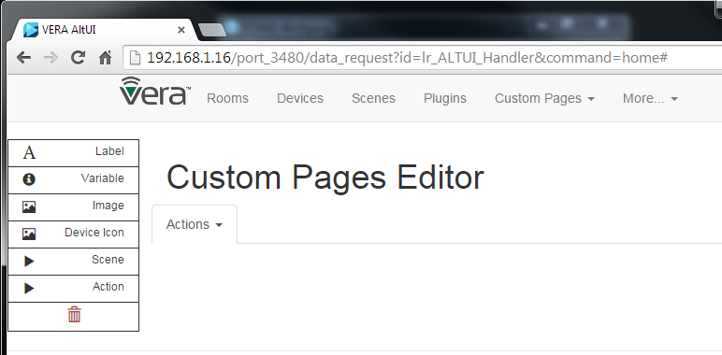

For now, you do not see any page , so let’s create one by going into the menu Actions.

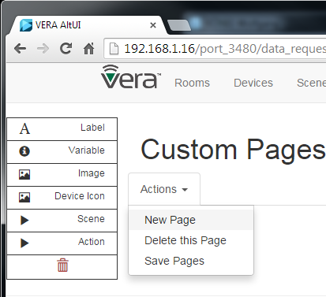

Click New page and your first page is created and is empty for now, but you see a grey canvas where you are going to position your controls.

You can create several pages, they will be displayed as “Tabs” you can select to move from one page to the other.

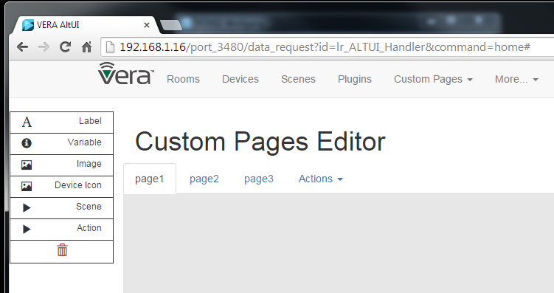

Now, lets position a few control on the panel. I have a IPhoneLocator plugin in my vera and I want to display the distance and the unit it is reporting. So you are going to select the first tool ( the A for labels ) and drag it into the canvas area. It will create a default label right at the position you left it.

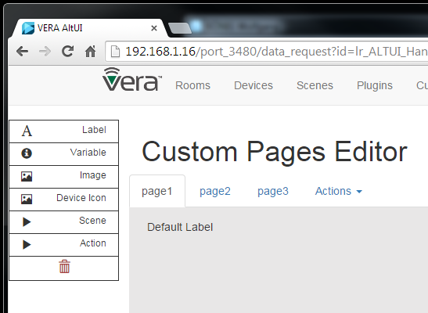

By clicking on it you can change this Default Label.

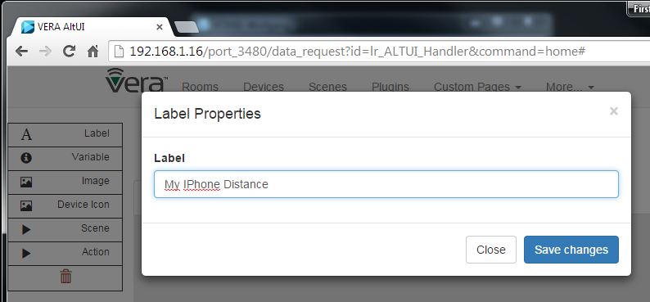

As expected the label has changed on the canvas. I now want to report a dynamic value coming from the device variable, I will use the second tool from the toolbox ( the I for Info, which is a variable ). I want the distance and the unit which are 2 different variables on this plugin so I will drag and drop 2 “Info” controls. You can move around a control after you have dropped it on the canva surface, just move them around as you want.

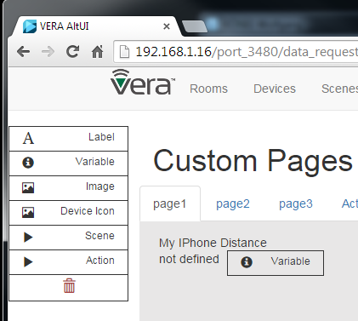

Double clicking on the variable, you can change the parameters so let’s now select the right variables.

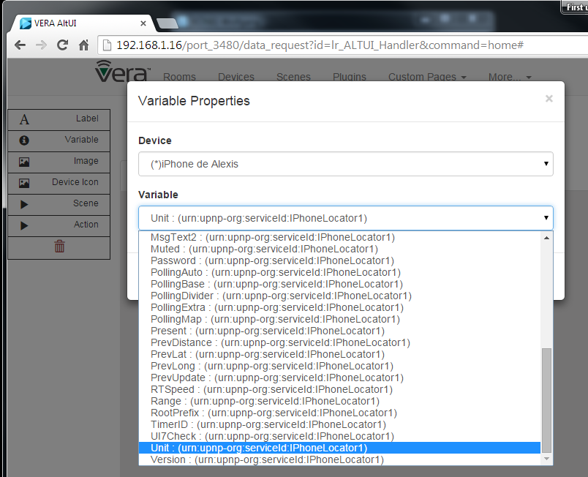

Let’s add the icon of the device ( which will follow the dynamic states as defined per the plugin author )

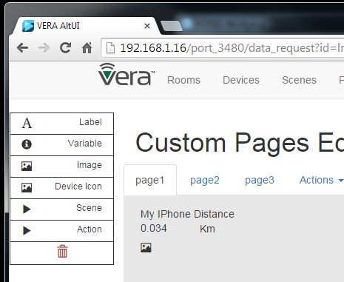

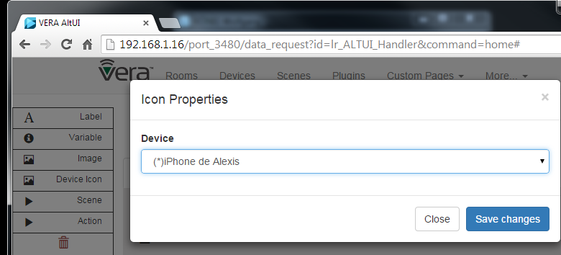

And Let’s add a mute button.

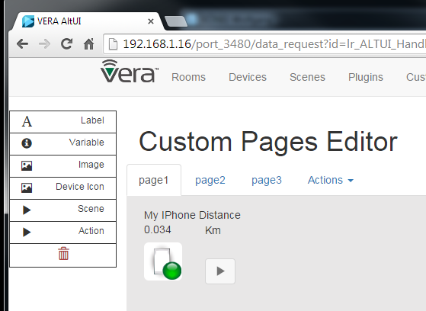

Which we need to configure to run the right UPNP action:

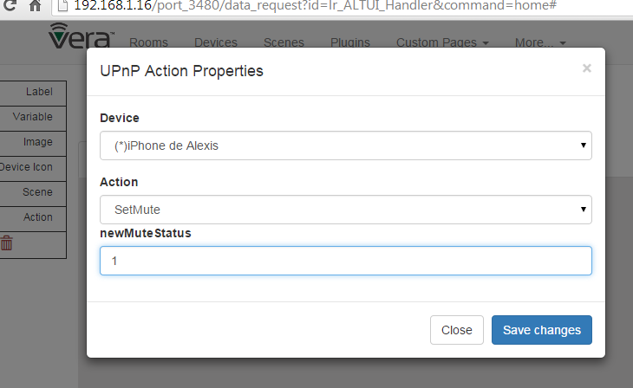

Et voila ( with a 3rd tool from the toolbox , image which can be any URL or data uri ( for embedded image) )

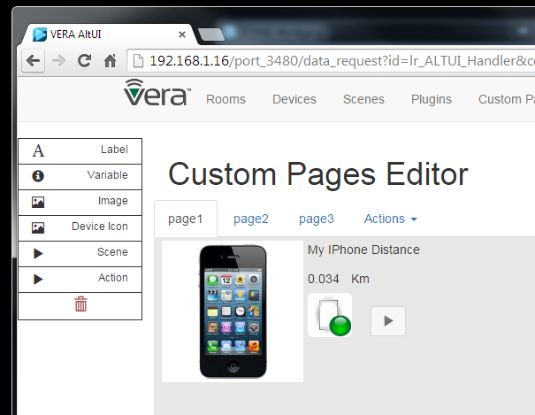

I now want to save it so that it can be persisted and reopened next time so I go into the Actions/Save menu.

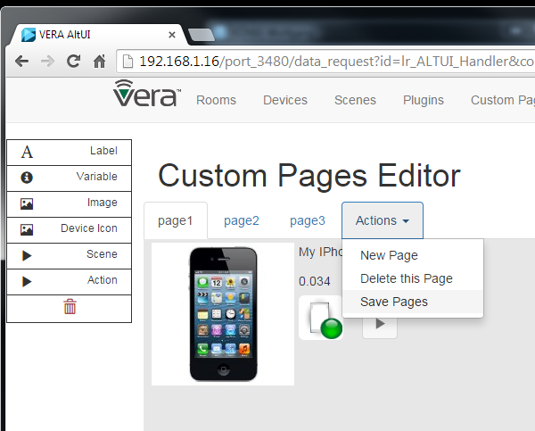

That is it , now the page is visible by the Custom Pages / “Use custom page” menu and you can close your browser and reopen it , it will still be there.

Now I can simply use it in read only mode and the button & icon are functional

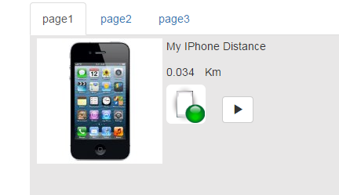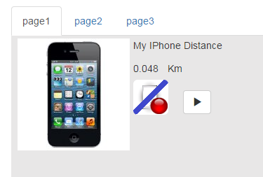

All pages definitions are stored in the LUA plugin variable “CustomPages”, you can see it from ALTUI and copy paste in a JSON online viewer if you are interested

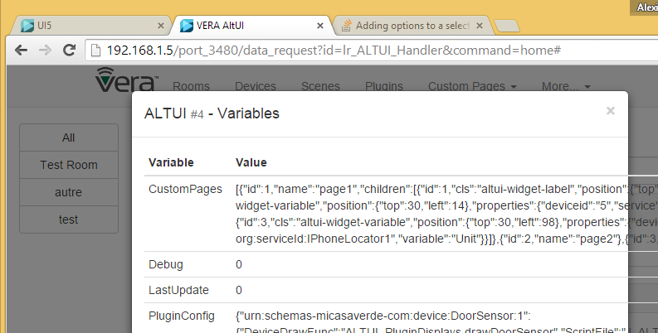

Other capabilities:

* Page Property menu items enables to:
  + Change a page name
  + Change a page background , any valid CSS3 background string is accepted. Solid color, grade, radiants, stripes, url(‘http://xxxx/image.png’) are valid. See the syntax of “**background”** css property

On this Picture you can see various important elements:

* The lasso (dotted line ) rectangle enabling the selection of multiple controls. Ctrl+Click is also supported
* The alignments tools in the left tool bar
* The resize handle at the bottom right corner of the image enabling you to size the image.

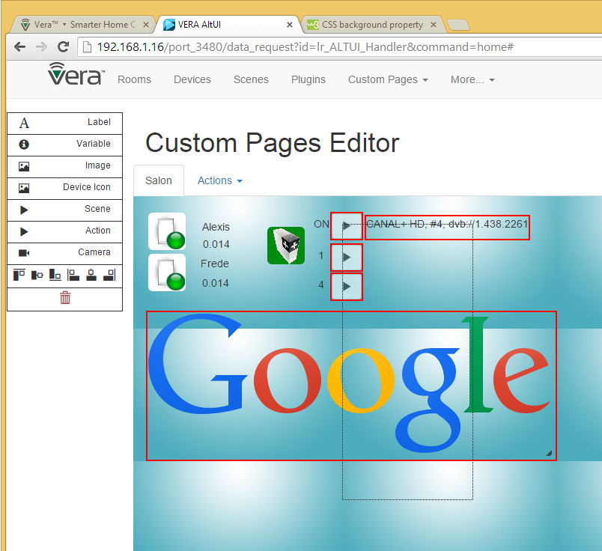

This will continue to evolve to add some more new tools ( which can be VERA related or even something totally different like a google chart gauge or whatever )

* New 2 state button tool
* New Google gauge with customizable min max & color ranges

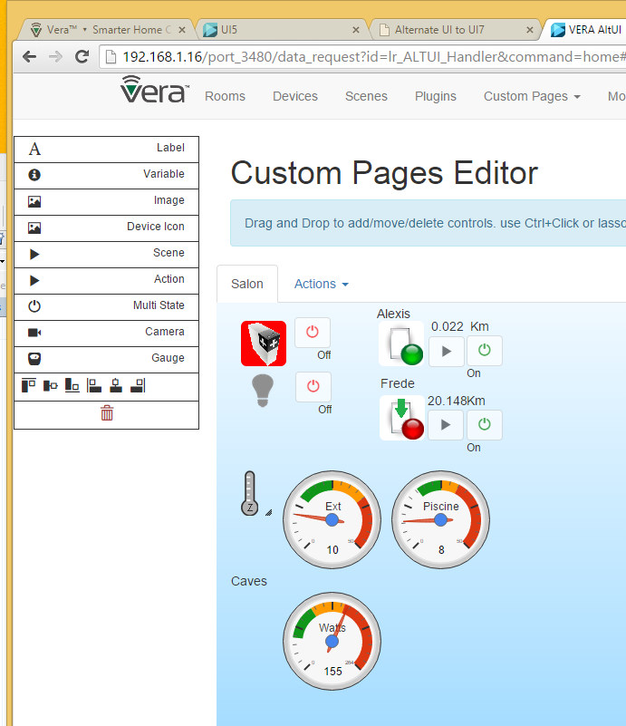

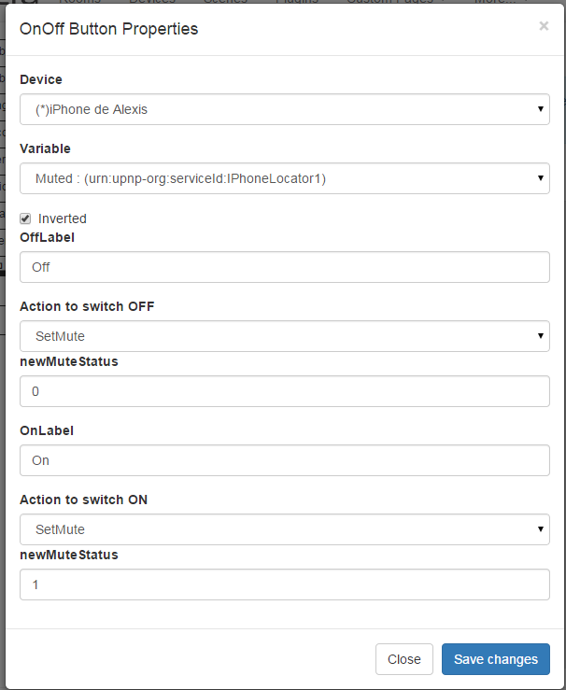

# UI5 Installation Instructions (similar for UI7)

PREFERED METHOD:

* Install from store http://apps.mios.com/plugin.php?id=8246
* Then override with latest version where xxx is the latest revision number : <http://code.mios.com/trac/mios_alternate_ui/changeset/xxxxx/?old_path=%2F&format=zip>

DETAILS

1. Upload all these files

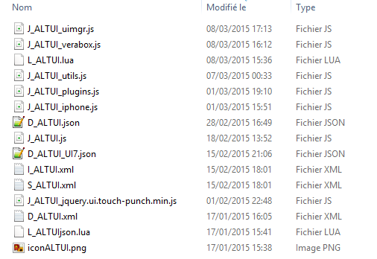

Example:

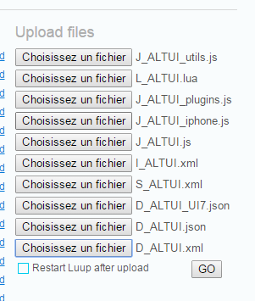

1. Create a device  
   ONLY DO THIS IF THE DEVICE DOES NOT ALREADY EXIST. If you installed from the store, the device has been created automatically for you

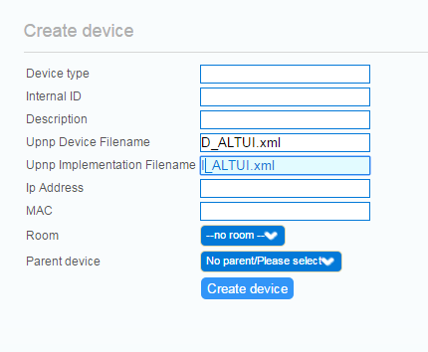

1. Reload lua



1. Find the device in UI5

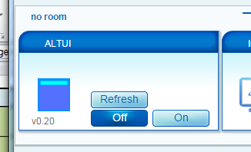

1. Open the settings tab

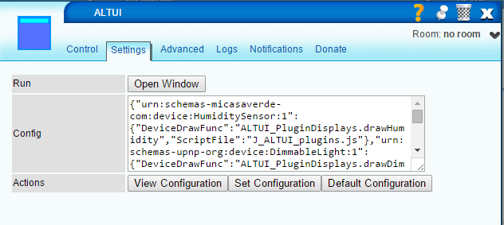

* View configuration : view the JSON configuration object in a JSON online viewer
* Set configuration : set the ALTUI plugin configuration
* Default : reset to default

1. Click on open window
   1. “modes” cannot work on UI5 of course but rest should be ok

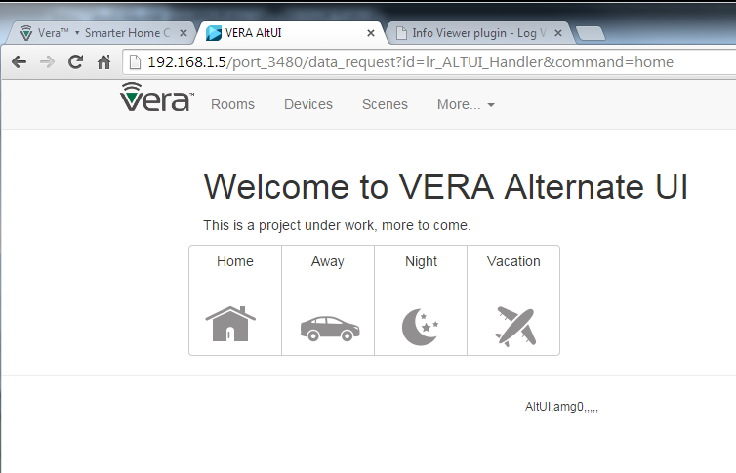

# Architecture and Source Code organization

## Data Flows

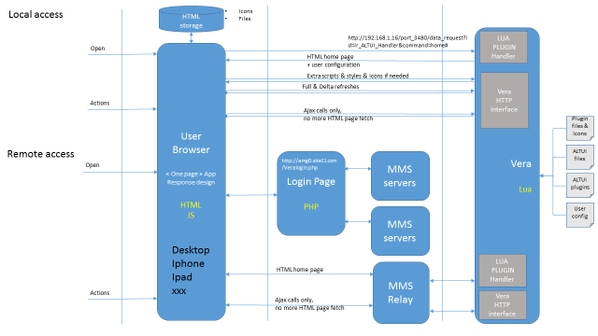

## Extensibility

### Mechanisms to extend

* Device dashboard drawing js function
* Device control panel js function
* New pages can be added ( Upnp devices, IP devices, Custom user pages , floor plan dashbnoard , google gauges etc )

### Javascript modules for customizable plugins

Plugins drawing are javascript modules providing function code and style css necessary. All the modules are loaded dynamically when needed

Plugins can customize/extend the drawings of device for 2 distinct scenario.

1. the small device box on the Device page
2. a control panel, dedicated for one device, having almost the full page to play with and display specific device status , controls, drawings etc... ( I added this "control panel" feature just in the drop down menu under Variable & Actions items. )

A default implementation is provided for both obviously. Right now the “control panel” one is useless and work in progress but I demonstrate the ability on 2 devices uses a custom control panel function. the Binary Light and the IPhone Locator. The point for me was to explain / demonstrate the extensibility of the architecture and how it would work. if JS developpers / plugin authors have interest to create a control panel for their device ( or some other device ), we can integrate their work easily in independent modules

Now a bit on the "how":

* each device type can have a custom javascript file. this is declared in the .LUA file L_ALTUI.lua. The “PluginConfig” LUA device variable contains the JSON object for this configuration and **can be modified to add new plugins.**
* in the configuration, for a given device type you can specify a script file (["ScriptFile"]="J_ALTUI_plugins.js",) , a small device box drawing function (["DeviceDrawFunc"]="ALTUI_PluginDisplays.drawBinaryLight",) , a full blown control panel drawing function (["ControlPanelFunc"]="ALTUI_PluginDisplays.drawBinLightControlPanel",) and a style function for your own CSS (["StyleFunc"]="ALTUI_PluginDisplays.getStyle",). All these are optional, default implementation is provided in any case. All these scripts & functions are dynamically loaded and executed when needed by the main page.
* The declared function can be qualified by any number of module name thus enabling to use the javascript module object pattern.
  + Function can be ‘myfunction()’
  + Or ‘myModule.mySubModule.myFunction()’ ( any depth )
* see examples of Style and drawing functions in J_ALTUI_plugins.js or J_ALTUI_iphone.js

Note:

* the ["DeviceDrawFunc"] takes input parameters like (devid, device) and must return a string which the HTML going into the small device box on the main page.
* the ["ControlPanelFunc"] works slightly different in order to give almost full DOM control to the code writer. It takes input parameters like (devid, device, domparent (jquery based) and must write directly its HTML code into the domparent object ( using $.(domparent).append(...) ). it felt more comfortable for the contralPanel function to really write in the DOM as they almost own the full page this time.

## Full Source code

all code available on <http://code.mios.com/trac/mios_ipx800/browser/trunk/AltUI> so feel free to try if you are interested.

### Source Files:

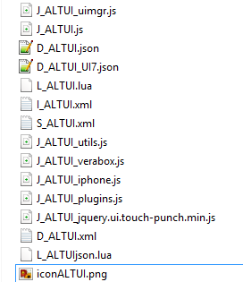

* **J_ALTUI_uimgr.js**
  + Implements the UIManager object. This object is in charge of all drawing on pages
    - Error messages
    - Device Drawing ( default & custom ) – manages the loading of JS files needed. Evaluate Icon conditions based on existing UI5 or UI7 descriptions.
    - Scene Drawing ( and editor )
    - Refresh UI ( when new data is arriving )
    - The main entry points ( pagesxxx() function per each page of the app )
    - House mode on UI7 only . the LUA plugin tells the application if we are on UI5 or UI7
  + It maintains internally the cache for device type information ( json, Upnp descriptions etc )
* **J_ALTUI.js**
  + The classical JS for the setting page of the UI5 or UI7 plugin
* **D_ALTUIxx.json**
  + The classical JSON files for the UI5 or UI7 plugin
* **L_ALTUI.lua**
  + The main plugin lua code
  + It is seldomly used, just to register a handler to act as a web server serving initially the first home page layout, and eventually responding to a few ( one so far ) ajax call from the client. The idea is to not use it as much as possible to offload the application work on the client side as explained in the initial project rules. VERA is small, our PC are big
  + It will act as the data persistent place where configuration and ( in the future ) user custom pages descriptions are stored & saved as device variable. UI7 can store and display JSON in its variable. UI5 has trouble to display it in the advanced tab as the string are not htmlENcoded but this is not a problem; we can manage this display & edit in the plugin JS setting page.
* **I_ALTUI.xml , S_ALTUI.xml** 
  + Classical device files.
  + A Reset uPNP action is implemented to restore configuration to default
  + In the future, we may need a few to manage user custom pages, not sure yet
* **J_ALTUI_utils.js**
  + Global utilities like string.format() addition, ro string.htmlEncode(), htmlDecode() addition to the string prototype
  + CSS Styles required by the application are managed here and injected dynamically ( avoid having to change the .LUA file and reloading every time )
  + It initializes the application by launching the Init() for the UIManager object and the VeraBox object
* **J_ALTUI_verabox.js**
  + Implements the communication with VERA
  + The UPnpHelper module
    - facilitates building of URL ( get set variables, run upnp, all the VERA Http calls basically including the HAG SOAP one )
    - Provides facitilies for plugin author like simple SetOnOff() , SetArm() methods
  + The FileDB module
    - A cache of dynamically loaded files ( D_xx files S_xx files, or whatever ). Key is the file name.
    - In the future, I intent to use HTML5 persistent storage to cache content on a even longer term basis ( even when user closes the browser )
  + The DialogManager module
    - To register dialog box html in the DOM
    - To refresh the dialog DOM if needed before displaying
    - A modal , not interruptible show_loading() hide_loading() spinner dialog
  + The VeraBox module
    - The core data load engine.
    - Manages getting the user_data and status_data using the loadversion versioning and various optimizations documented
    - Manages all information in a cache to not load it twice
    - Highly asynchronous, code executed in callback methods instead of waiting
      * getWeatherSettings : _getWeatherSettings,
      * getBoxInfo : _getBoxInfo,
      * getLuaStartup : _getLuaStartup,
      * getRooms : _getRooms, // in the future getRooms could cache the information and only call _getRooms when needed
      * getDevices : _getDevices,
      * getDeviceByID : _getDeviceByID,
      * getScenes : _getScenes,
      * getSceneByID : _getSceneByID,
      * getPlugins : _getPlugins,
      * getHouseMode : _getHouseMode,
      * setHouseMode : _setHouseMode,
      * getStatus : _getStatus,
      * getStates : _getStates,
      * evaluateConditions : _evaluateConditions, // evaluate a device condition table ( AND between conditions )
      * deleteRoom : _deleteRoom,
      * runScene : _runScene,
      * deleteScene : _deleteScene,
      * reloadEngine : _reloadEngine,
      * setStartupCode : _setStartupCode,
      * setScene : _setScene,
      * getCategoryTitle : _getCategoryTitle,
      * getDeviceTypes
      * initEngine()
  + UI5 and UI7 simulation apis
    - x.
* **J_ALTUI_IPhone.js**
  + The custom drawing functions for the IPHone locator plugin and the French Canal Plus control Plugin
  + Dynamically loaded when/if needed and configured in the LUA “PluginConfig” table to be loaded
* **J_ALTUI_Plugins.js**
  + Same but for all the out of the box devices provided by VERA ( bin lights, motion, temp sensors, heater , etc )
* **J_ALTUI_jquery.ui.touch-punch.min.js**
  + A small jquery 3rd party to make the ipad/iphone/ touch screen device compatible with the click event () so that touchend event can be used as a mouse click
* **J_ALTUI_loc_nn.js ( where nn is the 2 letter language code )**
  + All terms localization, file for the right language is dynamically loaded ( or preloaded by the LUA plugin if the lang=xx was on the url )

## Basic rules for developers:

I most welcome any programmers help in this project if they are interested in submissions. The rules are simple,

* use bootstrap grid model ( row / cols ) for full responsive design, I d like to keep it running from desktop to ipad to iPhone 4S screen !
* minimize additional JS framework : I am trying to use bootstrap, jquery, jqueryUI , a bootstrap validator , google chart, d3js , bootgrid, and that's all.
* use JS module pattern ( same as UI7 ) see example in the various modules. prefix private function with a '_' and public function with a naming convention doSomethingToSomethingElse()
* all CSS class: try to always use the prefix : altui-xxx-xxx etc
* avoid synchronous call when possible ( always possible almost )